Tanner Hintz
Mrs. Kalberer
EDU 310
December 1, 2016
Lesson Plan
Grade: 11
Subject: U.S. history/ World War II
Materials: Propaganda posters, PowerPoint software, computers

Standards:
- 9-12.1.2- Interpret and evaluate documents (e.g., primary and secondary sources, fact, fiction, or opinion) to enhance the understanding of social studies.
- 9-12.2.5- Trace the causes, course, and legacy of World War II (e.g., totalitarianism regimes, Pacific theater, European theater, home front).

Objectives:
- Students can identify and analyze propaganda posters.
- Students will learn how propaganda posters influenced people during war.

Learning activity:
- I will begin by telling the students that we will be analyzing propaganda posters today.
- I will then start explaining what propaganda posters are and the benefit they had.
- I will ask students different questions about propaganda posters and answer any questions they may have. Questions for students:
- How are political cartoons different from other cartoons in the newspaper?
- How are cartoons different from news articles?
- Next, I will inform students that we will be analyzing two propaganda posters as a whole class. Questions I may ask the students when analyzing the posters:
- Describe what is happening in the poster
- Explain the wording of the cartoon
- What is the overall message trying to imply?
- Clarify any symbols that are being portrayed?
- After demonstrating a couple propaganda posters as a whole class, I will have the students form groups. (2 or 3 or individually is fine)
- I will inform each student to grab a computer as they will now analyze propaganda posters individually or in their groups. They will use the link to go to google docs to log into their account. https://www.google.com/docs/about/.
- I will tell the students that I have shared a data based question guide for them on google docs.
- Students can work and collaborate together in their group to answer the questions about different propaganda posters.
- Propaganda posters and questions that will be on google docs:
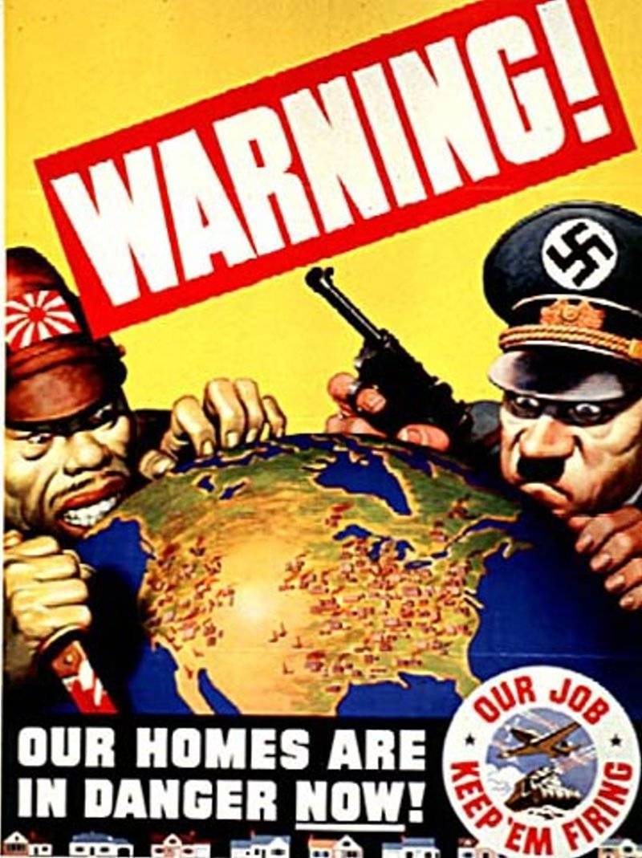
- Which countries are represented in this poster?
  - The countries who are represented in this poster are Japan and Germany, and United States/North America.
- Identify the characters, symbols and objects in the cartoon.
  - A few different symbols that are being identified are a knife, gun, United States, Japan, Hitler, Axis powers, and Hideki Tojo.
- What message/emotion is being conveyed?
  - This propaganda poster is supposed to put fear in United States citizens to keep up production. America is in mortal danger and citizens must work hard to counter the threat.
- Would a similar image have the same impact in today’s society? Why or why not?
  - Yes or no. Both answers can be correct.

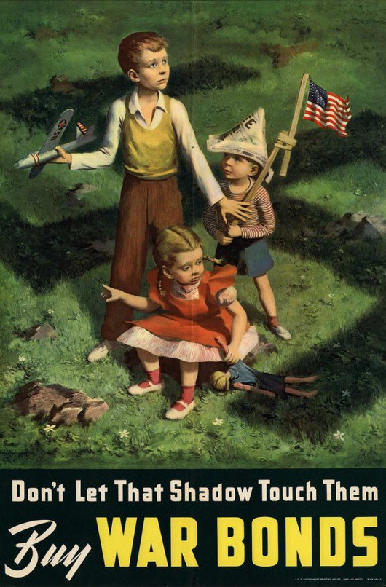
- What is the essential message of this illustration?
  - This message implies that if you don’t support the war financially, harm could come to your children. In addition, this poster puts fear into the American people.
- Describe several details which lead you to believe what you think the essential message is.
  - Children, Swastika, American flag, expression they have on their face.
- What symbols, key words or well-known images are used?
  - Swastika, American flag, children, War bonds.
  - Is the use of the symbol/ image/ word successful?
    - Answers can vary from yes or no.

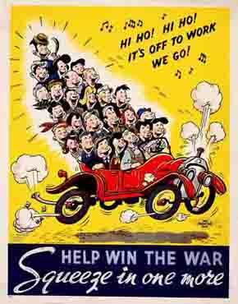
- What does this poster suggest Americans do and why?
  - This poster suggests that Americans should ride together to save gas in order to win the war.
- What feelings does the poster convey and list at least two examples from the poster which makes you think that?
  - This poster brings upon feelings such as joyfulness, fun, good times, happiness.
- How successful do you think this poster was during World War II?
  - I think this poster had an impact on many Americans.

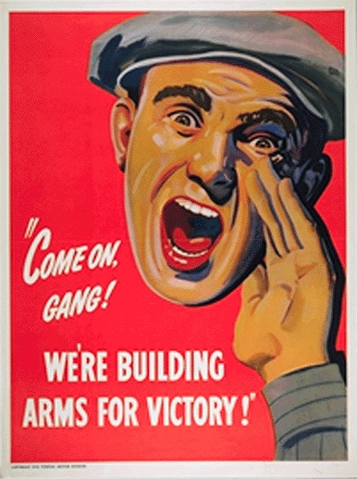
- For whom is this poster intended?
  - This poster is intended for United States citizens.
- What is the poster trying to get the audience to do?
  - The poster encourages everyone to join the war effort to build arms for victory.
- How would you change the image to make it more powerful?
  - Change the wording, add more people, different background/setting…etc.
- Would a similar image have the same impact in today’s society? Why or why not?
  - Answers may vary.

- Once students finish answering their questions, they can share their document/ answers to my google docs account.
- We will then have a classroom discussion about the answers they wrote.
- I will have students write an exit slip before they leave on their thoughts about my lesson and their thoughts on if propaganda posters were a useful tool during World War II?

Assessment:
- Analysis/answering of the questions
- Exit slip
Reflection:

