Senior Seminar

World War II
Final Unit Plan
Tanner Hintz

11/17/2016

World War II Unit Outline:
- Objectives for unit…………………………………………………………… Pg.3

- My teaching objectives………………………………………………………. Pg.3

- North Dakota Content and Achievement Standards: Social Studies…………. Pg. 4

- Teaching subjects/Research…………………………………………………Pg. 5-11
A. End of a “Great War”/Introduction
B. Germany invades Poland
C. Adolf Hitler
D. Holocaust
E. Pearl Harbor
F. Franklin D. Roosevelt
G. America in war
H. Harry Truman
I. Atomic Bomb
J. End of World War II

- Materials……………………………………………………………………..Pg. 12-39
A. Primary sources used in lesson plan
B. Propaganda posters used in lesson plan
C. Worksheet used in lesson plan
D. Assignments
E. Lesson plans
F. Test
G. Answer Key

- Bibliography…………………………………………………………………Pg. 40-44

Objectives for unit:
This unit plan will cover World War II from 1939 to 1945. The unit will consist of information on Germany invading Poland, rise of Adolf Hitler, the Holocaust, bombing of Pearl Harbor, Franklin Roosevelt, America waging war, Harry Truman, and the atomic bomb. In addition, this unit plan will expose the affect World War I had on World War II by explaining the political instabilities and economic collapse of countries.
Furthermore, this unit will establish the use of learning styles and multiple intelligences in education. The importance of incorporating lesson plans that have different learning styles/intelligences will help students achieve higher academic success. The unit has been developed for a sophomore grade history class in North Dakota.

Teaching objectives:
The major objectives for teaching social studies to students is having the ability to connect the content material to current real life/world situations. Therefore, teachers need to develop effective relationships with all students. Students who have developed a relationship will trust their teacher and are more likely to become engaged and succeed in his/her classroom. In addition, an educator’s objectives should be to promote citizenship education, and develop students critical thinking skills.
Furthermore, my passion for teaching will strive me to become the best possible role model for my students. I will contribute my work ethic and knowledge of history to help my students develop an understanding of the past, present, and future. Ultimately, I will need to have responsibility, an engaging personality, and leadership in order for me to become a quality educator.
North Dakota Content and Achievement Standards: Social Studies Grades 9-12:
The content standards and benchmarks are critical for an educator and his/her students. The standards provide the necessary information an educator has to teach. On the other hand, the students are expected to acquire knowledge and learn the social studies content. My duty as an educator is to make sure all students are comprehending the material, answer questions, and evaluate student progress. This unit plan will be incorporating the following standards:
9-12.1.1 Interpret and evaluate a variety of visual representations (e.g., charts, graphs, time lines, graphic organizers, maps, flow charts) of data.

9-12.1.2 Interpret and evaluate documents (e.g., primary and secondary sources, fact, fiction, or opinion) to enhance the understanding of social studies content.
9-12.1.3 Draw conclusions based on research processes (e.g., collect, organize, evaluate, and synthesize information)
9-12.1.4 Use media (e.g., oral, written, websites, computer simulations, multimedia resources) to access, record, analyze, and communicate information relating to social studies.
9-12.2.4 Analyze the major political, economic, and social developments that occurred between World War I and World War II (e.g., Red Scare, Roaring 20’s, Great Depression, New Deal)
9-12.2.5 Trace the causes, course, and legacy of World War II (e.g., totalitarian regimes; Pacific theater, European theater, home front)
Research:
End of a “Great War”
The Great War of 1914-1918 began a distinctive period for mankind and world history. The war was a crucial period for all European countries. Europe was a relatively peaceful continent prior to 1914, but the rise of Germany’s nationalism and imperialism started to take effect on other countries. “Germany under Kaiser Wilhelm II meant to challenge Great Britain’s world supremacy by creating industrial muscle at home, an empire abroad, and a mighty navy.” Ultimately, Germany decisively exposed the balance of power and peace within European countries.
World War I affected everyone around the world. More than thirty countries were involved in this huge epidemic. The war was primarily fought between the Triple Alliance (Germany, Austria-Hungary, and Italy) and the Triple Entente (Great Britain, France, and Russia). The United States was a neutral country, but eventually joined the war in 1917. “Germany understood the risk they were running, that this would probably bring the United States into the war.” Undoubtedly, Germany decided to enact unrestricted submarine warfare and would sink any ship in sight. As a result, “a German U-boat torpedoed the British passenger liner Lusitania, killing 1,198 passengers.” Consequently, the United States joined the Triple Entente against Germany.
The European nation was devastated by the brutal attacks from countries. Millions of casualties lay died, houses destroyed, and families torn apart. In January 1918, “[Woodrow] Wilson’s draft plan for peace, the Fourteen Points, was set down on paper by him.” He constructed the League of Nations which composed nations to come together and resolve conflict.
In the end, Germany was not able to succeed in war. “Germany was required to disarm, to surrender her overseas colonies, and to pay heavy reparations to her victorious enemies.” In June of 1919, Germany had signed the Treaty of Versailles. Germany was in total disbelief that they had lost the war. Germany was now in a rebuilding stage and was looking for a new leader to save them from their economic despair.
Germany Invades Poland
In 1939, the Second World War began as Hitler waged war against Poland. “Hitler had been pressuring that country for some time to join the German sphere, to no avail.” When the Poles rejected a German ultimatum on March 21, 1939, Hitler decided that they should be his first target. Hitler’s army appeared to perform brilliantly as Poland would fall, followed by Norway, the Netherlands, Denmark, Luxembourg, France, and Belgium, all within the first ten months of war.
Many German officers considered Poland an eternal enemy. Hitler decided to attack Poland by a widespread front. “Pitching superior numbers of troops and armour, and greater mobility, against a stubborn but out-gunned defence, this brought speedy results.” The German victories in 1939 were astounding. The Germans had developed tactical, operational, and command doctrines that were clearly superior to those of their enemies. He became convinced that his military talents were as great as those of his commanders. From this point forward, his willingness to listen to his best military minds would only diminish. Ultimately, behind the triumphs, however, serious weaknesses were already appearing.
Adolf Hitler
Adolf Hitler was one of the most influential leaders in world history. He dominated the beginning of the second World War due to his foreign and military strategies/policies, however, “Hitler wouldn’t have risen to power if not for World War I (1914-1918) and its aftermath.” He spoke on the importance of returning Germany to its prestige and fighting for what they lost in the Great War. “He began leading a new political party—the National Socialist German Workers’ Party, or Nazis for short.” His continuation of speeches drew in the German population. Eventually, Hitler was appointed chancellor in 1933 due to the Nazi support.
Hitler had exceptional and strategic ideas about military/political operations that would ultimately lead his country into World War II. “Germany’s future could only be assured by war, and that her enemies, Britain and France, were now gearing up for conflict.” Hitler believed he could fix the German country by himself. He formed a determination of never admitting the impossible and promoting risk taking to win war. In addition, his main goal was to be the aggressor of war and annihilate the enemy in order to move on. His country followed his every move and stayed loyal to him throughout the war. In the end, Hitler would become too thick headed to realize that his country would ultimately lose the war.
Holocaust
The Holocaust is defined as the mass killing of a race. During the second World War the Jews were the primary target of genocide in Europe. “Over 50 million people died as a result of total war between 1939 and 1945.” The Jews contributed to twelve percent of all deaths. The concentration camps were filled not only filled with Jews, but also the insane, gypsies, gays and lesbians, individuals with disabilities and Jehovah witnesses.
Most Jews in the low countries were laborers, craftsmen, merchants, and street vendors. They were normal people, but, nonetheless, were destroyed as quickly as possible when they arrived at the concentration camps. There were three designated death camps in Poland that included Belzec, Sobibor, and Treblinka. First, Belzec began operation in 1942 and was the initial camp to begin using gas showers to kill their victims. The German system of executing the Jews was ordinarily simple. “A train of resettlement workers arrived and the deportees were hauled out and forced to surrender their possessions in an orderly fashion… and [eventually] entered gas chambers disguised as showers.” Typically, the victims died within fifteen to thirty minutes by carbon monoxide poisoning and the corpses were burned in open-fire pits.
Next, Sobibor’s death camp began in 1942 and was more proficient than Belzec. Jews were efficiently gassed or shot when they arrived. In the fall of 1943, the prisoners revolted against the guards. “One after the other, nine SS men and two Ukrainian guards were isolated and killed.” As a result, the remaining guards shot the remaining prisoners, however, thirty men survived.
Lastly, the killing center of Treblinka was the most successful at killing Jews. They incorporated new technological improvements to the gas chambers. In the end, Treblinka had thirteen gas showers that poisoned innocent civilians. In addition, the Germans at Treblinka had almost killed one million Jews within one year of operation. Ultimately, the Jews from Europe who died at the killing centers were thrown into mass graves and were almost annihilated from the three designated death camps in Poland.
Pearl Harbor
Pearl Harbor was a devastating attack and shock to the United States of America. Therefore, an educator must interpret the mistakes and misinterpretations of American military to comprehend how the Japanese achieved victory. In early December, of 1941, the Japanese navy decided to end negotiations with the United States and attack Pearl Harbor’s fleet. The Japanese “had sunk, capsized, or damaged in varying degrees a total of eighteen warships- eight battleships, three light cruisers, three destroyers, and four auxiliary craft.” The United States faced a devastating setback to their navy and army. Nonetheless, the United States declared war on Japan the follow day.
The United States was now involved in World War II after the bombing of Pearl Harbor. The disaster in the Pacific was traumatic and devastating, however, this event welded the United States together. Ultimately, the Japanese had won a significant victory, but brought upon themselves a furious United States who wanted revenge.
Franklin Roosevelt
Franklin Roosevelt was born in 1882 and was inaugurated as the 32nd President of the United States on March 4, 1933. Roosevelt was a democrat who was pitted against Republican president Herbert Hoover in 1932. He was not recognized as a strong nominee, but, nonetheless, won against the discredited Hoover. “The action the new leader had in mind was bold, even revolutionary.” He was able to persuade and reassure the American people that he would end the Great Depression with his New Deal. His New Deal program created many different administrations and organizations. He formed the Civilian Conservation Corps, Civil Works Administration, Federal Security Agency, food-stamp plan, Medicare, Medicaid, and the Social Security Act throughout his presidency. In the end, Roosevelt contributed much of his time to the Great Depression and World War II. Ultimately, Roosevelt will always be remembered by his famous address to Congress after the bombing of Pearl Harbor.
Atomic Bomb
Harry Truman acquired the oval office after the death of Franklin Roosevelt in 1945. His actions were highly significant to help end World War II. Truman’s historic act of authorizing the use of the atomic bomb against Japan was life-changing. He imposed the United States as a superior power, however, he also demonstrated how corrupt our government thinking was.
In 1940, there was a scientific battle between the United States and Germany to build atomic energy. After the bombing of Pearl Harbor in 1941, the United States decided to coexist with another country. Therefore, “with American and British scientists working together we entered the race of discovery against the Germans.” Ultimately, the United States achieved their goal of creating an atomic bomb before Germany.
On August 6, 1945, the United States dropped an atomic bomb on Hiroshima. “Approximately 70,000 souls who, until that fateful moment, had been going about their normal, everyday lives-perished, and the world changed.” In addition, the United States dropped another atomic bomb three days later on Nagasaki. As a result, Japan had to surrender as their nation was destroyed. Ultimately, Truman’s decision of attacking Japan was an easy decision as this event led to the end of World War II.

End of World War II
There were multiple factors that contributed towards the second world war ending. First, the allies were destroying the axis powers in the air. “By the beginning of 1944 air warfare had turned overwhelmingly in favor of the Allies, who wrought unprecedented destruction on many German cities.” The allies were in total control of the air which forced Germany to keep their forces on the ground. Next, the allies pledged to continue fighting until the axis powers surrendered. “In the Mediterranean, the Allies followed up their African victory by the conquest of Sicily and the invasion of Italy.” As a result, the axis forces were cleared out and had nowhere to go. Lastly, the atomic bomb was feared by every country. “When Truman learned that an atomic bomb had been successfully tested on 16 July, he ordered that the weapon be used.” Undoubtedly, Japan and the axis powers were becoming over run by the allies and eventually had to surrender.

Primary Sources used in lesson plan:
- “I want to backtrack how I got involved in recalling my past and coming to terms with those experiences in the past. And what triggered it was my father’s death. He died in 1982. And I was in terrible shock. I couldn’t believe it. And all the years prior to his passing away I denied the Holocaust. I denied what happened to me. I didn’t want to think about it. I buried it.”

- “I would have rather died together with him than have to be separated from him. Because he was my sole companion. I had really no other companions… My whole structure was revolved around him. That was my structure of my life, from the day I was born until the age I was six… I never felt like I was a whole human being after that, myself. I never felt like I belonged anywhere. Because he was my structure.”

- “If they would pay me a million dollars, literally, I wouldn’t want to go back to the place where I was born because all I remember is hatred, murderers, people trying to kill me. They were like people turned into animals. And I do not want to step on that ground where I was born. And I really would never want to go back there. Because all I remember is horror, killings, and blood-shed.”
- “I don’t know how long we were going in the trains, but to me it was a lifetime. I think, the way I felt is: I was born on the train and I died on the train, because everything was such a mix-up.”

- “It was like a nightmare. Friends, relatives, just swelling up from hunger. First there was swelling, then they were dying… my father, too. He also died from hunger. He swell up like a balloon. And then they dry up, and then they lay like a vegetable. And people just step over them. It comes to a point that people just step over them and they don’t care anymore because everybody just cares for themselves.”

- “They tore the children, the babies away from the mothers. And there were screams. Could you imagine? Babies. Up to six years old they tore them away from mothers’ hands. Mothers were crazy. But they had no choice… they were going from one house to the next. And we sat there and we listened to it.”

- “First of all, we felt that if there’s going to be a war, it is going to be like a Blitzkreig. It’s going to last a month or so, and then it will be over. So we felt, well, if it is only going to last a little while, the Jews will survive. They always somehow do. We didn’t think it was going to last long, first of all. Number two, we didn’t believe what [Hitler] said or what he was going to do, it’s going to really happen. We didn’t believe it.”

- “I recall when they were piling us into the car, they wanted everybody to move back so they could put more people in. Eventually people kept going back, but there was no more room. I do recall they fired across, to make more room so [they] shoved another batch of people in. I remember a good percentage of people died. For three days, people defecated on the floor. For three days, we didn’t have any food or water. I remember that the thirst was the overwhelming thing.”

- “They marched us to a train station, packed us in cattle cars, and we just kept riding the train for days. There was again a stop. It was late at night. We went through a big town and we stopped at the train station. We must have been there for a few hours, and I looked through the small, little windows in the cattle car, and I happened to look into an apartment. I saw a family sitting by the table eating. There were several children and adults. And I was thinking to myself, ‘Will I ever be able to find my parents and sit again at a table as a free human being?’”

- “Everything went fast. They did not give you a chance to think or to contemplate where you are going, what you are going to do. They brought us there to destroy our bodies and soul. We did not work. We stood in line for six hours- six hours daily. Three hours in the morning and three hours in the afternoon. It’s very difficult to stand when you are a healthy person, but when you are hungry and you haven’t eaten for two, three days, it’s very difficult. And many times we didn’t stand. We just fell.”

Propaganda posters used in lesson:
- B.
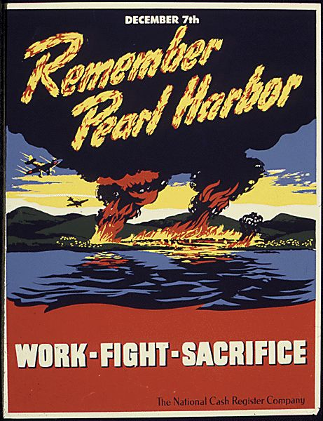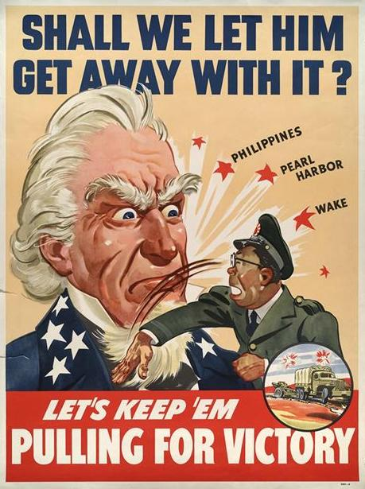

C.
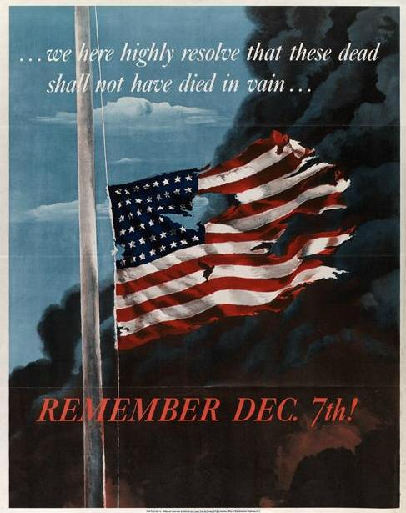

D. E.
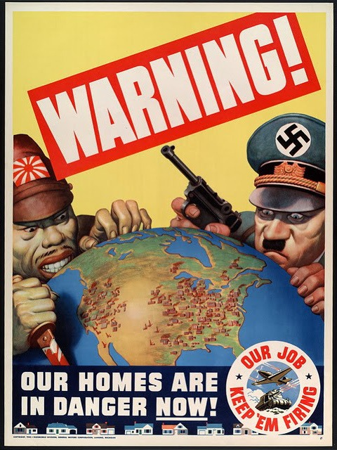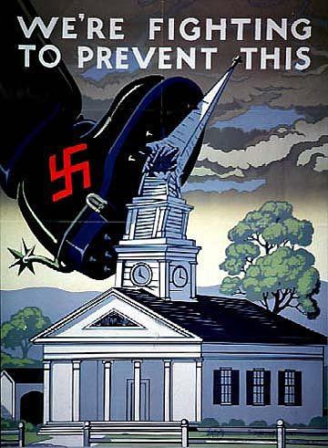

F.
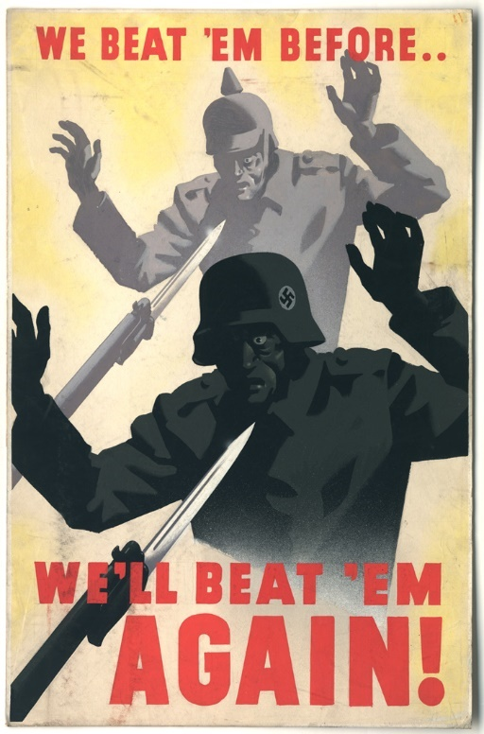

Worksheet used in lesson:
file:///C:/Users/Owner/Downloads/worldwar2vocab.pdf.

Assignments:
Lesson 1:  End of the Great War/ Introduction. | Kahoot to check comprehension.  Listen to lecture and notes on vocabulary.  Two paragraph journal entry.
Lesson 2: Germany Invades Poland | Data Based Question lesson.
Lesson 3: Adolf Hitler | Analyze propaganda posters.  What are the significances?  Notes/lecture on Adolf Hitler.  Half page journal entry.
Lesson 4: Holocaust | Investigating and examining primary sources.  Discussion.  Half page journal entry.
Lesson 5: Pearl Harbor | Identify/analyze propaganda posters.  Lecture/notes  Half page journal entry.
Lesson 6: Franklin Roosevelt | Venn Diagram.  Lecture and Cornell notes.
Lesson 7: Atomic Bomb | Debate/research.
Lesson 8: End of World War II | Worksheet.  Lecture/notes.  Review/discussion.

Lesson plan #1- Introduction
Grade: 11
Subject: U.S. History
Materials needed: Computer, projector, PowerPoint, chart handout.

Standards:
9-12.1.1- Interpret and evaluate a variety of visual representations (e.g., charts, graphs, time lines, graphic organizers, maps, flow charts) of data.
Objectives:
The students will be able to examine charts of World War I.
The students will build an understanding of basic vocabulary on World War I and World War II.

Learning Activity:
- The teacher will begin class by having students use a computer or their cell phones to take a ten question non-graded quiz on kahoot. This quiz is to check their comprehension on the World War I and World War II. https://kahoot.it/#/.
- The teacher will then ask the students; why did countries want to fight in another war after the historic costs from World War I?
- I will handout a World War I chart to students that provides the casualties of different countries.

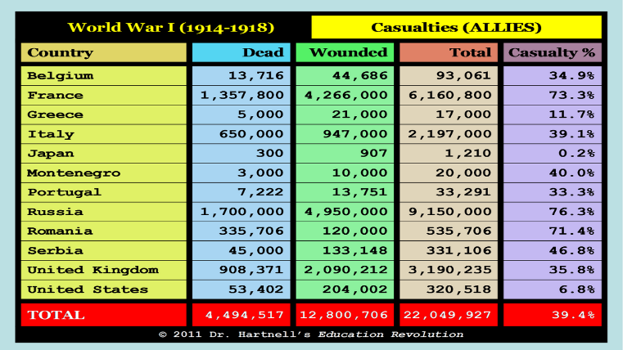

- The teacher will prompt the students to form groups of two or three and discuss their thoughts and opinions of why we might fight another world war.
- After discussion, I will call upon each group to offer their thoughts and explain their reasoning. I will write them on the board to create a list of ideas.
- I will then have students return to their desk. We will begin a PowerPoint presentation on the vocabulary of World War II. This will lay the foundation for the rest of the lessons.
- Students will need to write two paragraphs in their journal on why they believe nations wanted to fight in another World War.
Assessment:
Participation in group discussion/ offering their thoughts and ideas.
Completing a two paragraph journal entry.
Reflection:

Lesson #2
Grade: 11
Subject: U.S. History/ Germany invades Poland
Materials needed: Computers
Standards:
9-12.1.3- Draw conclusions based on research processes (e.g., collect, organize, evaluate, and synthesize information)
9-12.1.4- Use media (e.g., oral, written, websites, computer simulations, multimedia resources) to assess, record, analyze, and communicate information relating to social studies.
9-12.2.5- Trace the causes, course, and legacy of World War II (e.g., totalitarianism regimes; Pacific theater, European theater, home front)

Objectives:
Identify the event(s) that led to World War II.

Learning activity:
- Students will begin by forming groups of two (They can work alone as well). If there is an odd number of students, then one group can have three.
- Next, each student will grab a computer in the classroom. They will use the link to go to google docs to log into their account. https://www.google.com/docs/about/.
- I will tell the students that I have shared a data based question guide for them on google docs.
- Students will then research the questions in order to find the answers. Students can work and collaborate together in their group.
- My driving questions are: What caused the beginning of World War II?
- Why were so many nations involved in World War II?
- Who were the members of each alliance?
- What are Adolf Hitler’s main goals/ideas for his country in World War II?
- Did Hitler’s aspirations lead his country to war?
- Once students finish answering the questions, they can share their document/answers to my google docs account.
- If all students finish answering the questions, then we will have a classroom discussion about the answers they found.

Assessment:
Stays on topic and answers the questions presented.
Supports opinions with historical or primary source information.

Reflection:

Lesson #3
Grade: 11
Subject: U.S. History/ Adolf Hitler
Materials needed: Propaganda poster handouts, PowerPoint software.

Standards:
9-12.1.2 Interpret and evaluate documents (e.g., primary and secondary sources, fact, fiction, or opinion) to enhance the understanding of social studies content.

Objectives:
Students will assess and identify basic propaganda posters.
Students will learn how propaganda posters influenced people during war.
Students will understand basic knowledge about Adolf Hitler.

Learning Activity:
- The teacher will begin by writing the word “propaganda on the board”.
- The teacher will ask the students what they think the word means/define the word.
- After the students define the word, I will then show them the propaganda poster “D” on page 16.
- I will briefly explain the poster by describing the overall message, emotions of the poster, and the possible effects the poster may have on other countries.
- Next, I will provide the students with two different propaganda poster handouts.
- The students will then analyze and assess the posters. Students are allowed to work alone or have groups of 2 or 3.
- I will ask the students to answer the following questions:
  - Describe what is happening in the poster.
  - Explain the wording of the cartoon.
  - What is the overall message trying to imply?
  - Clarify any symbols that are being portrayed?
- Once students finish answering the questions, we will have a whole class discussion on their observations. I will ask the students what they believe the importance of political cartoons have on wars/people.
- In addition, the students should have recognized that each picture involved Germany.
- I will tell the students that we are going to take notes on Adolf Hitler’s uprising, involvement in World War I, foreign and military strategy and politics.
- Lastly, students will need to write a half page report/journal entry on the importance of propaganda posters.

Assessment:
Students answer propaganda poster questions with clarity and thoughtfulness.
Students complete their half page report on the importance of political cartoons.
Reflection:
This lesson was designed for students who are visual learners. Visual “students can relate concepts that they see daily to their learning process.”
Lesson #4
Grade: 11
Subject: U.S. History/ Holocaust
Materials: Primary sources for all students.
Standards:
9-12.1.2- Interpret and evaluate documents (e.g., primary and secondary sources, fact, fiction, or opinion) to enhance the understanding of social studies content.
9-12.2.5- Trace the causes, course, and legacy of World War II (e.g., totalitarianism regimes, Pacific theater, European theater, home front).

Objectives:
Students analyze multiple primary sources.
Students understand the meaning of primary sources.
Students understand the results of the holocaust.

Learning Activity:
- The teacher will begin by introducing and describing the Holocaust.
- The teacher will prompt the students that we will be reading primary sources of people from World War II.
- I will prompt the students that we will be begin by reading an important source together. (Primary source 10 on page 15) I will provide a preview of the source by handing out 6 different sentences from the primary source. Once every student has a sentence of the source, I will tell the students to walk around the room and compare sentences. The students job is to figure out what the article is about by reading their sentence and linking them to their classmates sentences.
- Once students have mingled around the room for a few minutes, I will prompt them to form groups of five. I will then ask them what they believe the passage was about.
- While students are discussing, I will pass out the primary source of Edith P.’s testimony. I will allow a few minutes for reading, then ask the groups to share their comments about the text.
- I will then pass out the remaining primary sources (1-9) found on page 12-15 to each group. Groups will read/analyze and discuss the primary sources together.
- Lastly, we will come back as a whole class to discuss the content of each article and how each person may or may not have been effected by the Holocaust. In addition, I will ask the students what was the purpose of reading primary sources?
- I will have the students write a half page journal entry on their thoughts/ideas about reading people’s testimony’s from the Holocaust. What would they have done if they were put into those positions? What is the purpose of reading primary sources?
Assessment:
Participation in group discussion.
Students write a journal entry on their thoughts about the Holocaust.
Reflection:
This lesson was designed for students who are spatial learners. “Spatial intelligence might be improved through the relatively simple strategy of fieldtrips which focuses specifically on developing students’ powers of observation.”
Lesson #5
Grade: 11
Subject: U.S. History/ Pearl Harbor
Material: Propaganda posters, PowerPoint software.

Standards:
9-12.1.2- Interpret and evaluate documents (e.g., primary and secondary sources, fact, fiction, or opinion) to enhance the understanding of social studies.
9-12.2.5- Trace the causes, course, and legacy of World War II (e.g., totalitarianism regimes, Pacific theater, European theater, home front).

Objectives:
Students develop an understanding of the significance of Pearl Harbor
Students can identify and analyze propaganda posters.

Learning activity:
- The teacher will have the students form their own groups of three or four once they come to class.
- The teacher will prompt the students to share or think what they know about Pearl Harbor in their group.
- To help students understand more about Pearl Harbor, the teacher will pass out three different propaganda posters from World War II (A, B, C on page 16).
- The students will analyze and discuss what each poster is trying to portray/overall message.
- Once small groups finish discussing, we will come back as a whole class to discuss the posters. We will discuss the overall message, the emotions being portrayed, and the effects the poster might have on a country.
- Once discussion is over, the teacher will lecture while the students write notes on Pearl Harbor. We will cover the who, what, where, when of Pearl Harbor. In addition, the teacher will discuss the mistakes the Americans and Japanese made and the effects of Pearl Harbor on the United States.
- Students need to write a half page journal entry on their thoughts about the attack on Pearl Harbor.

Assessment:
Students complete their journal entry on time and provides their thoughts and ideas on the Pearl Harbor attack.
Reflection:
This lesson plan was designed for students who are linguistic learners. Students typically use “linguistic symbols and codes to contextualize language and make meaning.”

Lesson #6
Grade: 11
Subject: U.S. History/ Franklin Roosevelt
Material: PowerPoint software, Venn Diagram for each student, computers.

Standards:
9-12.1.4- Use media (e.g., oral, written, websites, computer simulations, multimedia resources) to access, record, analyze, and communicate information relating to social studies.
9-12.2.4- Analyze major political, economic, and social developments that occurred between World War I and World War II (e.g., Red Scare, Roaring 20’s, Great Depression, New Deal).

Objectives:
Students understand the significant roles each president had throughout their presidency.
Learning Activity:
- The teacher will begin the class by lecturing on Franklin Roosevelt while the students take Cornell notes. The teacher will talk about Roosevelts rise to presidency and the contributions he had throughout his years in office.
- After notes, I will prompt the students to take out a piece of paper to draw a Venn diagram.
- The students will be comparing Franklin Roosevelt and Harry Truman. Students will need to have 10 differences and 5 similarities between these two men.
- Students are able to use computers to do their research.
- Once students finish, we will have a classroom discussion on the similarities and differences between the two presidents.

Assessment:
Students completing the Venn diagram with all 10 differences and 5 similarities.

Reflection:

Lesson #7
Grade: 11
Subject: U.S. History/Atomic Bomb
Materials: Computers and textbooks.

Standards:
9-12.1.3- Draw conclusions based on research processes (e.g., collect, organize, evaluate, and synthesize information).
9-12.1.4- Use media (e.g., oral, written, websites, computer simulations, multimedia resources) to assess, record, analyze, and communicate information relating to social studies.
9-12.2.4- Analyze the major political, economic, and social developments that occurred between World War I and World War II (e.g., Red Scare, Roaring 20’s, Great Depression, New deal).
9-12.2.5- Trace the causes, course, and legacy of World War II (e.g., totalitarianism regimes; Pacific theater, European theater, home front).

Objectives:
Students develop an understanding on the atomic bomb dropping in World War II.

Learning Activity:
- The teacher will begin the class by informing students that we are going to have a debate on the atomic bomb dropping. I will assign half of the class who will support the dropping of the bomb and the other half who will oppose the bomb dropping.
- The teacher will provide a short lecture on the who, what, where, when ideas on the atomic bomb.
- The teacher will then prompt the students to use computers or the textbook to research more information about the atomic bomb dropping on Japan. The debate will occur the following day.
- The teacher will decide who wins the debate by listening to each sides arguments and who provides more conclusive supporting details. The winning team will be awards 3 bonus points for the test.

Assessment:
Students research about the atomic bomb.
Students participate in the debate. Provide their thoughts, ideas or gives examples.

Reflection:
This lesson was designed for students who are interpersonal learners. “Interpersonal intelligence is having the ability to understand people and empathize with them.”

Lesson #8
Grade: 11
Subject: U.S. History/ End of WWII
Materials: PowerPoint software, notes, textbook, worksheet.

Standards:
9-12.2.5- Trace the causes, course, and legacy of World War II (e.g., totalitarianism regimes; Pacific theater, European theater, home front).

Objectives:
Students comprehend vocabulary and different events throughout World War II.
Learning Activity:
- The teacher will begin by lecturing on the factors that led and contributed to World War II ending.
- The teacher will then hand out a worksheet to the students. file:///C:/Users/Owner/Downloads/worldwar2vocab.pdf. (This resource can be found on page 18 as well). The worksheet will be due the day of the test.
- If students complete the worksheet before others, they can study for the test.
- Before the end of class, we will review for the test.

Assessment:
Completion of worksheet.
Reflection:
TEST
Name_______________
World War II Test
11/15/16
True or False
Read each question before answering. Circle T if the statement is true and F if the statement is false. (1 point each)

T F 1. Roosevelt was president when the United States used the atomic bomb
T F 2. Roosevelt served three elections as president
T F 3. Only Jews were targeted in concentration camps
T F 4. Men, Women, Children of all ages were sent to concentration camps to be executed.
T F 5. Harry Truman decided to drop the bomb on Japan
T F 6. This war was the first time women were allowed to take part in combat
T F 7. Pearl Harbors base is located in the Atlantic Ocean
T F 8. Genocide is commonly used to describe the Holocaust
T F 9. Britain, France, Soviet Union made up the allies
T F 10. Isolationism is typically used to avoid political commitments to other nations

Multiple Choice
Read each question and circle the correct answer. (2 points each)
- What was the treaty that ended World War I?
A. Treaty of London
B. Treaty of Versailles
C. Treaty of Athens
D. Second Geneva Convention

- What decade did Hitler become the essential dictator?
A. 1930s
B. 1920s
C. 1910
D. 1940s

- What event began World War II?
A. Atomic Bomb
B. Pearl Harbor attack
C. Germany invades Poland
D. Assassination of Archduke Ferdinand

- Who was the primary leader during World War II for the United States?
A. Harry Truman
B. John F. Kennedy
C. Franklin Roosevelt
D. Theodore Roosevelt

- Who took over his presidency after his death?
A. Franklin Roosevelt
B. Harry Truman
C. Theodore Roosevelt
D. Dwight Eisenhower

- When did Pearl Harbor occur?
A. November 7, 1941
B. December 9, 1941
C. December 6, 1941
D. December 7, 1941
- The main axis powers of World War II consisted of?
A. Germany, Italy, Japan
B. Germany, Soviet Union, Japan
C. United States, Italy, Japan
D. Germany, Finland, Japan

- What type of warfare did Germany use on their enemies in World War II?
A. Airborne warfare
B. Blitzkrieg
C. Nuclear warfare
D. Chemical warfare

- How long did World War II last for?
A. 4 years
B. 5 years
C. 6 years
D. 7 years

- Britain and France declared war on Germany after Hitler invaded what country?
A. Finland
B. United States
C. Belgium
D. Poland
Matching:
Pick the best letter to answer the following questions. (1 point each)
____1. Adolf Hitler A. Axis
____2. Great Britain, France, Soviet Union B. Atomic Bomb
____3. Word meaning “lightning war” C. Allies
____4. Germany, Italy, Japan D. Blitzkrieg
____5. Nuclear weapon E. German Nazi dictator

Short Answer:
Write a minimum of one paragraph for each question (5 points each)
- What factors contributed to the end of World War II?

- What caused the United States to come of isolationism and join the war?

- What happened during the Holocaust?

Answer Key:
True and False-
1. F
2. F
3. F
4. T
5. T
6. F
7. F
8. T
9. T
10. T
Multiple Choice:
1. Treaty of Versailles
2. 1930s
3. Invasion of Poland
4. Franklin Roosevelt
5. Harry Truman
6. December 7, 1941.
7. Germany, Italy, Japan
8. Blitzkreig
9. 6 years
10. Poland
Matching:
1. E
2. C
3. D
4. A
5. B
Short Answer:
- There are multiple answers.
- Atomic bomb
- Allies were winning decisive battles
- Allies had air control
- Hitler was not listening to his military commanders

- The attack on Pearl Harbor on December 7, 1914.

- Answers may vary:
- The Jewish population was executed. They were taken to death/concentration camps to work or die.

Bibliography
1. Allen, B. Thomas. “How many will die.” Naval History 29, no. 4 (2015): 36-41. MasterFILE Premier. (Journal Article 1)
2. Barricks Insurance Services. World War II propaganda poster. Accessed November 17, 2016.
http://www.barricks.com/December_7th_6.html. (Primary Source)
3. Brown, Bryan. “Could Hitler happen again.” New York Times Upfront 147, no. 1 (2014): 18-21. MasterFILE Premier. (Journal Article 2)
4. C, Arnold. His testimony found in Witness: Voices from the Holocaust by Joshua M. Greene. 11 years old when transferred to Auschwitz. New York: The Free Press (2000). (Primary Source)
5. Capio, J. Ralph. “The atomic bombings of Japan.” Airpower Journal 9, no. 2 (1995): 9. MasterFILE Premier. (Journal Article 3)
6. Chapman, Carole. “Hitler as war leader.” History Review (2011): 6. MasterFILE Premier. (Journal Article 4)
7. Dear, I.C.B. World War II. New York: Oxford University Press, 1995. (Book 1)
8. Derrien, M. Monika. “Sense of place as a learning process: examples from the Narratives of Bosnian Immigrants in Vermont,” Leisure Sciences 36, no.2 (2014): 107-125. Academic Search Premier. (Journal article 8)
9. Dwork Deborah and Robert Jan Van Pelt, Holocaust: a history. New York: W.W. Norton and Company, 2002. (Book 2)
10. Family Research Project. World War II propaganda posters. Accessed November 11, 2016.
http://blakebettsfamily.weebly.com/world-war-ii-propaganda-posters.html. (Primary Source)
11. Ferguson, Niall. The War of the World: Twentieth-Century conflict and the descent of the West. New York: The Penguin Press, 2006. (Book 3)
12. Friedman, S. Saul. A History of the Holocaust. Portland: Vallentine Mitchell, 2004. (Book 4)
13. G, Annette. Her testimony found in Memory Perceived: Recalling the Holocaust by Robert N. Kraft. Connecticut: Praeger (2002). (Primary Source)
14. Greene, M. Joshua, Witness: Voices from the Holocaust. New York: The Free Press, 2000 (Primary Source book)
15. Harrison III, Henry. “Incorporating animation concepts and principles in STEM education.” Technology Teacher 69, no. 8 (2010): 20-25. Academic Search Premier. (Journal article 7)
16. Hartnell, Benjamin. Scramblin’ thru history. World War I casualty chart. Accessed November 17, 2016. http://www.nuttyhistory.com/world-war-i.html.
17. Hernandez, Beverly. World War II matching activity worksheet. Accessed November 17, 2016. file:///C:/Users/Owner/Downloads/worldwar2vocab.pdf
18. Howard, Michael. The First World War: A very short introduction. New York: Oxford University Press, 2002. (Book 5)
19. Johnson, Paul. A History of the American people. New York: Weidenfeld and Nicolson, 1997. (Book 6)
20. K, Bessie. Her testimony found in Memory Perceived: Recalling the Holocaust by Robert N. Kraft. Connecticut: Praeger (2002). (Primary Source)
21. K, Helen. Her testimony on Germany invades Poland. Found in Witness: Voices from the Holocaust by Joshua M. Greene. Born Warsaw, Poland, 1924, age 15. New York: The Free Press (2000). (Primary Source)
22. Kraft, N. Robert. Memory Perceived: Recalling the Holocaust. Connecticut: Praeger, 2002. (Primary Source book)
23. L, Eva. Her testimony on the Holocaust. Found in Memory Perceived: Recalling the Holocaust by Robert N. Kraft. Connecticut: Praeger (2002). (Primary Source)
24. Lim, Y.T. Kenneth. “Augmenting Spatial Intelligence in the Geography classroom,” International research in Geographical and Environmental education 14, no.3 (2005): 187-199. Academic Search Premier. (Journal article 9)
25. Megargee, P. Geoffrey. Inside Hitler’s High Command. Kansas: University Press of Kansas, 2000. (Book 7)
26. Menevis, Ipek. “Do age and gender influence multiple intelligences?” Social behavior and Personality: an international journal 42, (2014): 9-19. Academic Search Premier. (Journal article 10)
27. North Dakota Content and Achievement Standards: Social Studies. Official Portal for North Dakota State Government 2007. Accessed November 17, 2016. https://www.nd.gov/dpi/uploads/87/Soc_studies.pdf.
28. P, Edith. His testimony of the Holocaust. Found in Witness: Voices from the Holocaust by Joshua M. Greene. New York: The Free Press (2000). (Primary Source)
29. Prange, W. Gordon. Pearl Harbor: The verdict of History. New York: McGraw-Hill Book Company, 1986. (Book 8)
30. R, Jacqueline. Her testimony on the Holocaust. Found in Memory Perceived: Recalling the Holocaust by Robert N. Kraft. Connecticut: Praeger (2002). (Primary Source)
31. Roark L. James. The American Promise: A History of the United States. New York: Bedford/St. Martin’s. 2012. (Book 9)
32. S, Martin. His testimony on the Holocaust. 11 years old when transferred from Skarzysko- Kamjenna concentration camp to Buchenwald. Found in Witness: Voices from the Holocaust by Joshua M. Greene. New York: The Free Press (2000). (Primary Source)
33. S, Nina. Her testimony on the Holocaust. Found in Memory Perceived: Recalling the Holocaust by Robert N. Kraft. Connecticut: Praeger (2002). (Primary Source)
34. S, Sabina. Her testimony on the Holocaust. Found in Memory Perceived: Recalling the Holocaust by Robert N. Kraft. Connecticut: Praeger (2002). (Primary Source)
35. Super lessons: lesson plans for the superhero high school teacher. World War II propaganda posters. https://superlessons.wordpress.com/tag/world-war-ii/. Accessed November 17, 2016. (Primary Source)
36. The Gilder Lehrman Institute of American History. World War II propaganda poster commemorating Pearl Harbor. Accessed November 17, 2016.
https://www.gilderlehrman.org/history-by-era/world-war- ii/resources/world-war-ii- commemorating-pearl-harbor-1941. (Primary Source)
37. Truman S. Harry. “Atomic bombing of Hiroshima announcement.” Atomic bombing of Hiroshima announcement (2009): 1-3. Academic Search Premier. (Primary Source)
38. Wartime Propaganda: Pearl Harbor. World War II propaganda poster. Accessed November 17, 2016. http://wtfarthistory.com/post/13874427754/wartime-propaganda-pearl-harbor. (Primary Source)
39. Williams, Althea. “Sobibor: The other great escape.” History Today 63, no. 10 (2013): 4-5. MasterFILE Premier. (Journal article 5)
40. “World War II.” Columbia Electronic Encyclopedia, 6th edition (2016): 1-4. MasterFILE Premier. (Journal article 6)
41. World War II Propaganda, Cartoons, Film, Music, & Art. World War II propaganda posters. Accessed November 17, 2016. http://www.teacheroz.com/WWIIpropaganda.htm. (Primary Source)

North Dakota Content and Achievement Standards: Social Studies. Official Portal for North Dakota State Government 2007.
James L. Roark, The American Promise: A History of the United States (New York: Bedford/St. Martin’s, 2012), 655.
Michael Howard, The First World War: A very short introduction (New York: Oxford University Press, 2002), 72.
James L. Roark, The American Promise: A History of the United States, 658.
Paul Johnson, A History of the American People (New York: Weidenfeld & Nicolson, 1997), 648.
Michael Howard, The First World War: A very short introduction, 115.
Geoffrey P. Megargee, Inside Hitler’s High Command ( Kansas: University Press of Kansas, 2000), 67.
I.C.B. Dear, The Oxford Companion to World War II (New York: Oxford University Press, 1995), 890.
Bryan Brown, “Could Hitler Happen Again,” New York Times Upfront 147, no. 1 (2014): 18-21. Academic Search Premier
Ibid., 18
Carole Chapman, “Hitler as War Leader,” History Review 71 (2011): 44-49. Academic Search Premier.
Saul S. Friedman, A History of the Holocaust (Portland: Vallentine Mitchell, 2004), 1
Deborah Dwork, Holocaust: A History (New York: W.W. Norton & Company, 2002), 287.
Althea Williams, “Sobibor: The other Great Escape,” History Today 63, no.10 (2013): 4-5. Academic Search Premier
Gordon W. Prange, Pearl Harbor: The Verdict of history (New York: McGraw- Hill Book Company, 1986), 1.
Niall Ferguson, The War of the World (New York: The Penguin Press, 2006), 222.
Harry S. Truman, “Atomic Bombing of Hiroshima Announcement,” (2009): 1-2. Academic Search Premier.
Ralph J. Capio, “The Atomic Bombings of Japan,” Airpower Journal 9, no. 2, 1-6. Academic Search Premier.
Columbia Electronic Encyclopedia, 6th edition. 2016. “World War II” Academic Search Premier.
Ibid., 1.
Thomas B. Allen, “How many will die,” Naval History 29, no.4 (2015): 36-41. Academic Search Premier.
Jacqueline R. Her testimony on the Holocaust. Found in Memory Perceived: Recalling the Holocaust, by Robert N. Kraft. (2002), 66.
Annette G. Her testimony on the Holocaust. Found in Memory Perceived: Recalling the Holocaust, by Robert N. Kraft. (2002), 69.
Sabina S. Her testimony on the Holocaust. Found in Memory Perceived: Recalling the Holocaust, by Robert N. Kraft. (2002), 82.
Bessie K. Her testimony on the Holocaust. Found in Memory Perceived: Recalling the Holocaust, by Robert N. Kraft. (2002), 101.
Eva L. Her testimony on the Holocaust. Found in Memory Perceived: Recalling the Holocaust, by Robert N. Kraft. (2002), 107.
Nina. Her testimony on the Holocaust. Found in Memory Perceived: Recalling the Holocaust, by Robert N. Kraft. (2002), 122.
Helen K. Born Warsaw, Poland, 1924. Age 15, Germany invades Poland. Found in Witness: Voices from the Holocaust, by Joshua M. Greene. (2000), 32.
Martin S. 11 years old when transferred from Skarzysko-Kamienna concentration camp to Buchenwald. Found in Witness: Voices from the Holocaust, by Joshua M. Greene. (2000), 108.
Arnold C. 11 years old when transferred to Auschwitz. Found in Witness: Voices from the Holocaust, by Joshua M. Greene. (2000), 111.
Edith P. Found in Witness: Voices from the Holocaust, by Joshua M. Greene. (2000), 129.
Henry L. Harrison III, “Incorporating animation concepts and principles in STEM education,” Technology teacher 69, no. 8 (2010): 20-25. Academic Search Premier.
Kenneth Y.T. Lim, “Augmenting Spatial Intelligence in the Geography classroom,” International Research in Geographical and Environmental education 14, no.3 (2005): 187-199. Academic Search Premier.
Monika M. Derrien, “Sense of place as a learning process: examples from the Narratives of Bosnian immigrants in Vermont,” Leisure Sciences 36, no. 2 (2014): 107-125. Academic Search Premier.
Ipek Menevis. “Do age and gender influence multiple intelligences?” Social behavior and Personality: an international journal 42, (2014): 9-19. Academic Search Premier.

